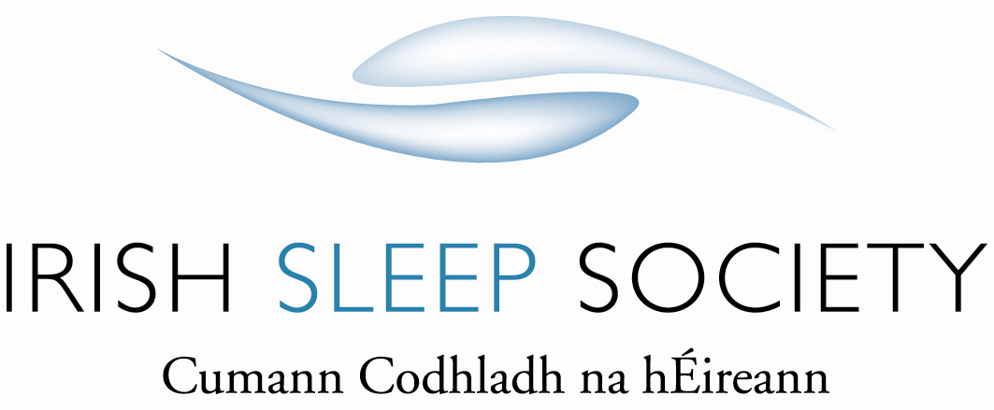

Saturday 27th January 2018 - Carlton Hotel Dublin Airport

8.15 – 8.50 Registration, coffee and industry exhibition. Exhibition Hall
8.50 – 9.00 Welcome. Lecture Theatre
9.00 – 9.30 Trisomy 21 and OSA.
Dr Sheila Javadpour and Lisa Farell.
Paediatric Respiratory Consultant and NIV nurse specialist. Lecture Theatre
Our Lady’s Children’s Hospital, Crumlin, Dublin.
9.30 – 10.00 Orthofacial Surgery for OSA - from neonates to adults. Lecture Theatre
Mr Dylan Murray.
Craniomaxillofacial surgeon and dentist.
Childrens University Hospital, Temple St and Mater Hospital.
10.00 – 10.30 Coffee break and industry exhibition. Exhibition Hall
10.30 – 11.00 Recent developments in Irish Sleep Medicine. Lecture Theatre
Prof Liam Cormican- President.
Respiratory and Sleep Physician.
Connolly Hospital, Blanchardstown, Dublin.
11.00 – 11.45 Sleep – offences and defences. Lecture Theatre
Dr Chris Idzikowski PhD.
Sleep specialist, author, honorary post in OU School of Law.
Belfast.
11.45 – 12.30 Lunch and industry exhibition.
12.30 – 1.30 Insomnia subtypes and brain mechanisms – perspectives on Lecture Theatre
Insomnia disorder.
Prof Eus Van Someren PhD.
Head of Department, Sleep and Cognition.
Netherlands Institute for Neuroscience, Amsterdam.
1.30 – 2.30 Business Meeting Lecture Theatre

